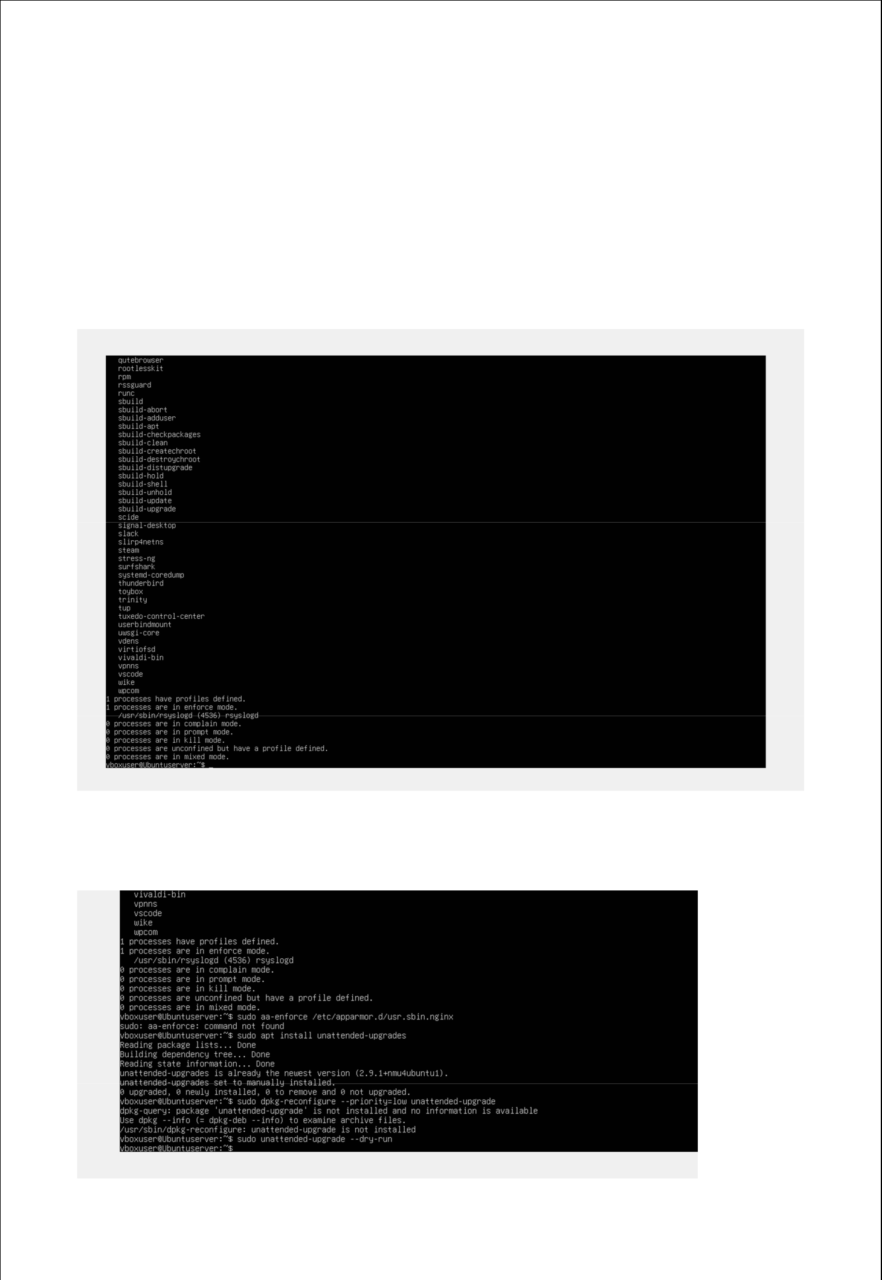
Week 5

Security Hardening

Goal:

The main goal of this phase id to implement extra hardening measures in order to improve system security.

Automa c updates:

To guarantee prompt patching, automatic security updates were turned on.
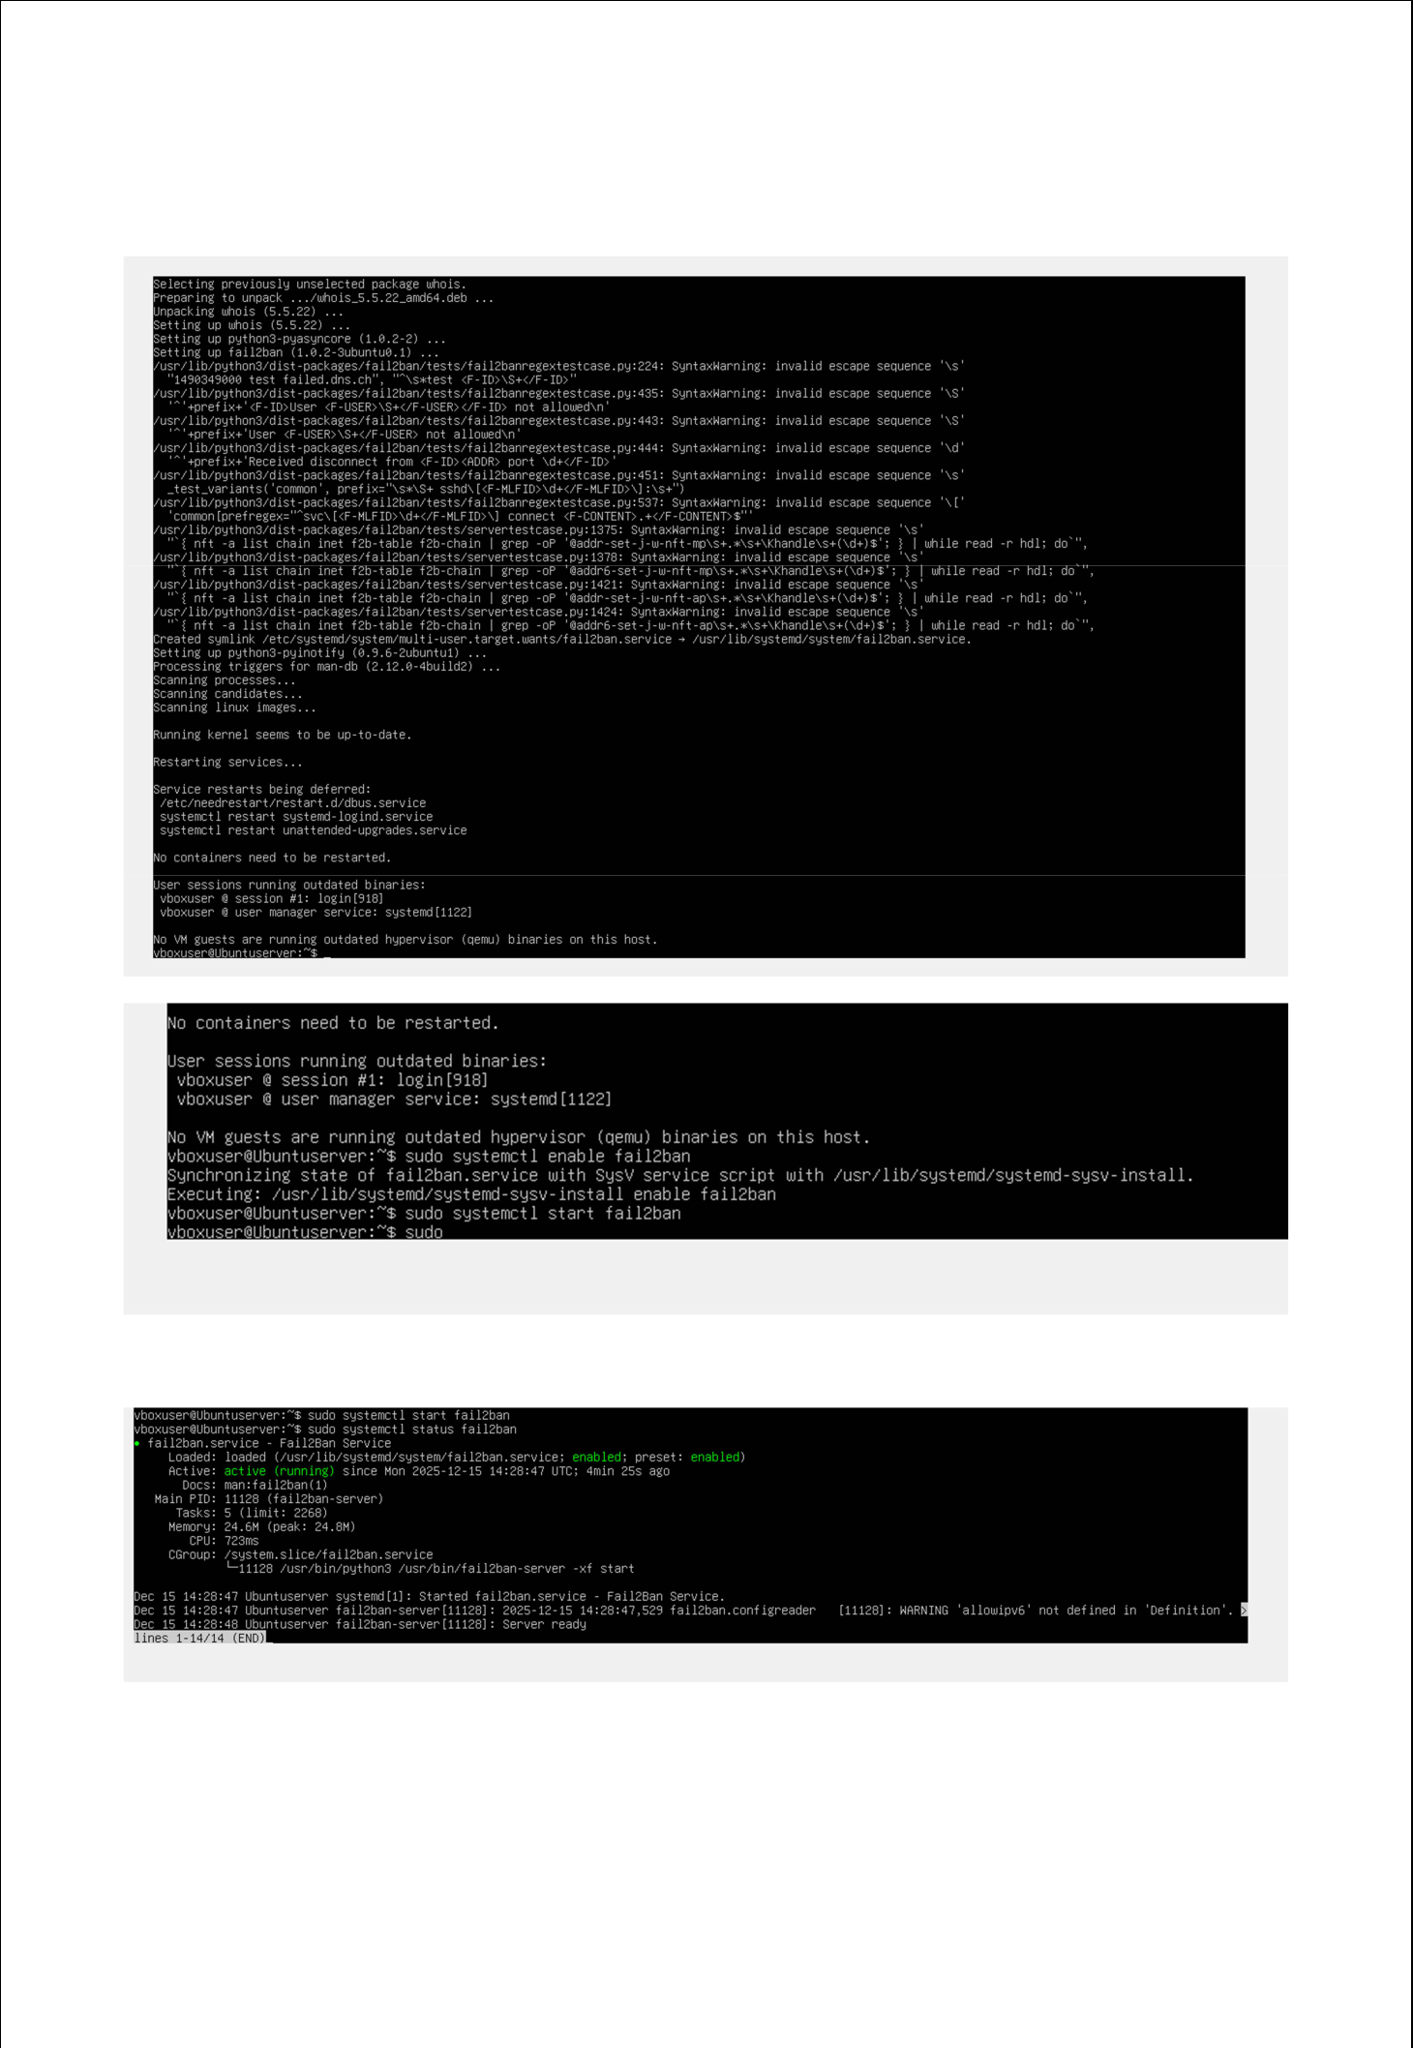

Installing fail2ban:
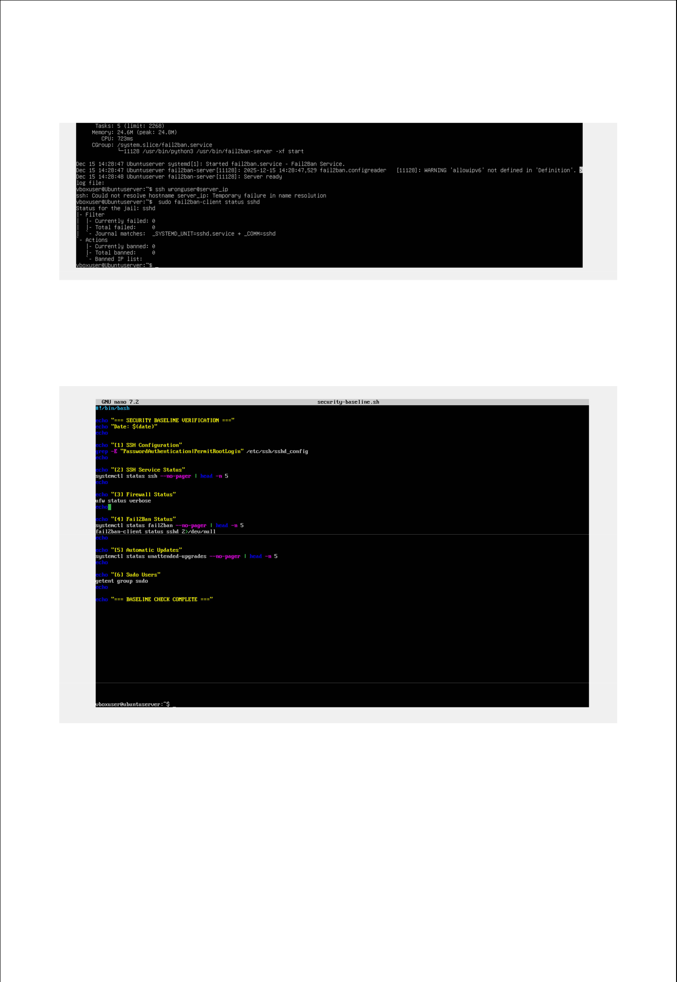

Shows banned ips:

Security Baseline script:

I have created the security baseline verifica on script to validate security se ngs.
